

**Lab no.: 5 Date: February 13, 2024**

**Write a menu-based program to simulate the basic operations of Stack.**

**Stack** is a linear data structure that follows a particular order in which the operations are performed. The order may be **LIFO (Last In First Out)** or **FILO (First In Last Out)**. **LIFO** implies that the element that is inserted last, comes out first and **FILO** implies that the element that is inserted first, comes out last.

The basic stack operations are:

* Push
* Pop

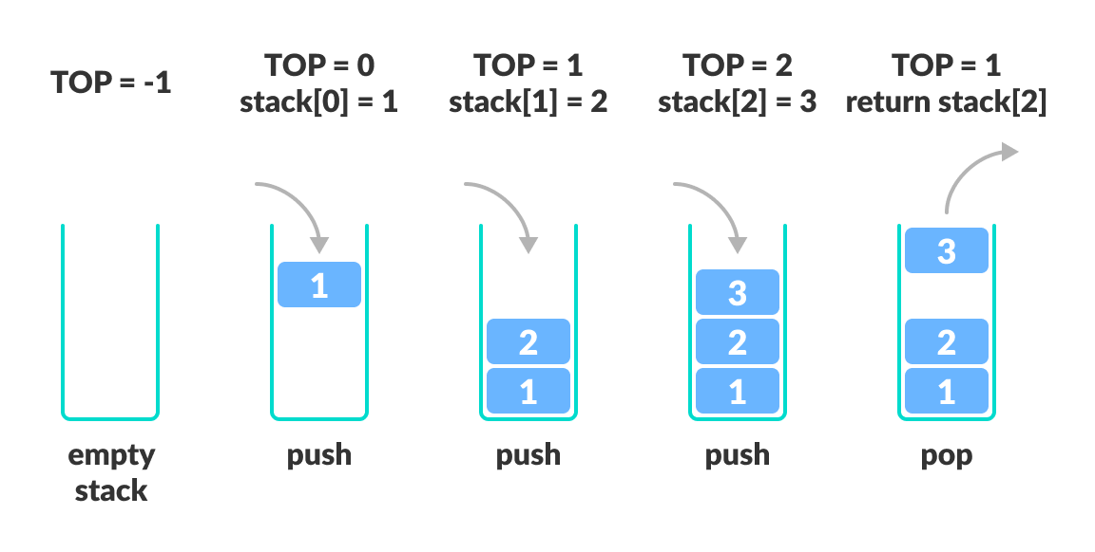

Figure 1: Stack Operation

**Programming Language: C**

**IDE: Microsoft Visual Code**

**Source code:**

#include <stdio.h>

#define MAXSIZE 10

int stack[MAXSIZE];

int top = -1;

// to push data

void push(int ltop)

{

if (ltop == MAXSIZE - 1)

printf("\nThe stack is full.\n");

else

{

printf("Enter the data: ");

top++;

scanf("%d", &stack[top]);

}

}

// to pop data

void pop()

{

if (top == -1)

printf("\nThe stack is empty.\n\n");

else

{

printf("%d", stack[top]);

top--;

}

}

// to display data

void display(int ltop)

{

printf("The data are:\n");

for (int i = 0; i <= ltop; i++)

{

printf("%d ", stack[i]);

}

}

int main()

{

int choice;

while (1)

{

printf("\n....STACK OPERATIONS...\n");

printf("1.Push\n");

printf("2.Pop\n");

printf("3.Display\n");

printf("4.Exit\n");

printf("Enter you choice: ");

scanf("%d", &choice);

switch (choice)

{

case 1:

push(top);

break;

case 2:

pop();

break;

case 3:

display(top);

break;

case 4:

exit(0);

break;

default:

printf("you didnt choose the right option.");

}

}

}

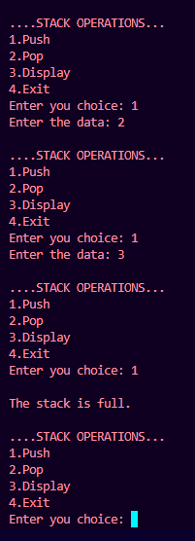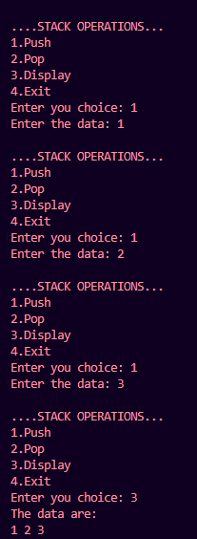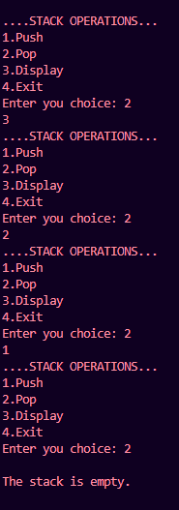

**Outputs:**